Package Details
Package Name | Chardham Fix Departure
Origin | Delhi
Destination Covered | YAMUNOTRI - GANGOTRI - KEDARNATH – BADRINATH
Traveling Mode | By Road
Variant | Deluxe
Group Size & Departure Dates | 11 May 2024// 23 May 2024// 04 June 2024//16 June 2024
Package Cost (Per Person)
Single  Occupancy | Double  Occupancy | Triple  Occupancy | Child With Extra Bed (5-11 Years) | Child Without Extra Bed (5 Years)
44500/- | 34500/- | 30500/- | 22500/- | 9500/-

Ex Delhi {11 Nights /12 Days}
Short Tour Itinerary:-
Day 01: Delhi Haridwar
Day 02: HaridwarBarkot
Day 03: BarkotSyanachattiYamunotriSyanachattiBarkot
Day 04: BarkotUttarkashi
Day 05: UttarkashiGangotriUttarkashi
Day 06: UttarkashiGuptkashi
Day 07: GuptkashiGaurikundKedarnath
Day08: KedarnathGaurikundGuptkashi
Day 09: GuptkashiChoptaBadrinath
Day 10: BadrinathJoshimathAuliJoshimathRudraprayag
Day 11: RudraprayagDevoprayagRishikesh
Day 12: Rishikesh Delhi/Delhi Airport.
==================================Tour End===================================
Main Sightseeing:Kemptyfall, Shivguffa, KashiVishwanath Temple (Uttarkashi&Guptkashi), Harsil, Radi Top,Chopta, PanchParyag, YogdhyanBadri, VradhBadri, Joshimath, Auli (By Cable car) Govindghat (Way to Hemkund and Valley of Flowers.) Mana Village, Devoparayag, Rishikesh.
Chardham Rout Map:
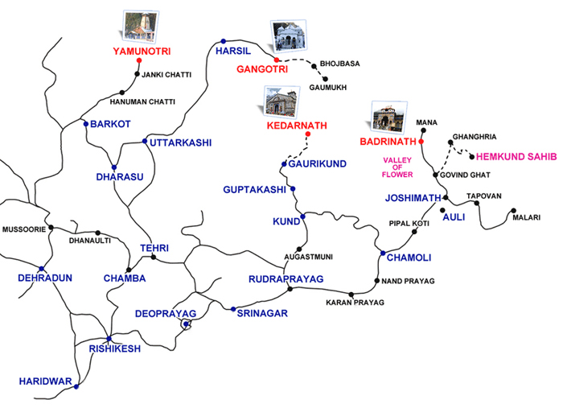

Detail Itinerary
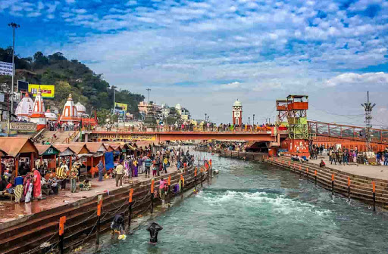

Day 01: Delhi Haridwar (220kms/6-7 hrs drive one way) Height: 310 MTS.
Report at Delhi Railway Station, Ajmeri Gate Side at 09:00 Hrs. Meet our driver at station and drive to Haridwar. Check into the hotel arrival in Haridwar. Evening visit Mansa Devi Temple & Ganga aarti at Har Ki Pauri. Overnight stay at Haridwar.
Haridwar: The holy city of Haridwar translates to "Gateway to God," and the breathtaking city, replete with temples, is a magnet for religious pilgrims from all over the globe. Religious festivals hold even further draw, and tourists can’t helped but be compelled by the city’s aura of intense spirituality. Haridwar is one of the seven holiest places of the Hindus, located on the banks of River Ganges. The sheer numbers of people gathering around Har-ki-PairiGhat give Haridwar a chaotic but reverent feel.

Day 02: HaridwarBarkot (210kms/7-8hrs drive one way) Height: 1352 MTS.

Morning after breakfast drive for Barkot via Mussoorie, enroute visit Mussoorie Lake &Kempty Fall in Mussoorie. Later drive straight to Barkot. Check in to your pre-book hotel. Overnight stay at Barkot.

Mussoorie:-The name Mussoorie is often attributed to a derivation of Mansūr, a shrub which is indigenous to the area. The town is often referred to as Mansuri by most Indians.In 1803 the Gorkhas under Umer Singh Thapa conquered the Garhwal and the Dehra, whereby Mussoorie was established. On 1 November 1814, a war broke out between the Gorkhas and the British. Mussoorie were evacuated by the Gorkhas by the year 1815 and were annexed to the district of Saharanpur by 1819.
For More Information click to Mussoorie Tourism
Barkot Weather - Generally pleasant in summer, the temp. ranges from 25-30 degree Celsius, Winter: The Days are pleasantly cool but the nights are cold,temp. ranges from 10 deg to 05 deg.

Day 03: Barkot/Yamunotri / Barkot {36kms drive & 6kms Trek (one side)} Height: 3235 MTS.
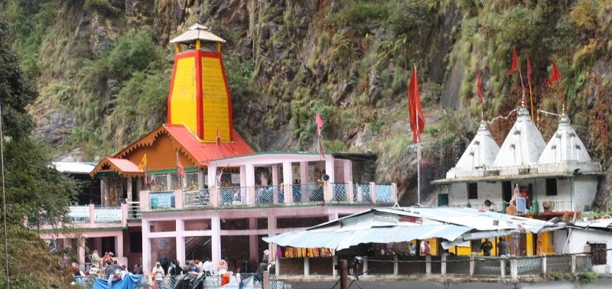
Early morning after breakfast, drive to Jankichatti / Phoolchatti& startyour trek from here to Yamunotri (6kms) (Either by walk or by horse or by Doli at own cost). After taking bath in JamunabaiKund's warm water and having "Darshan" of "Yamunaji" return to Jankichatti by trek. Later drive towards Barkot, Overnight stay at Barkot.

Yamunotri Temple: Maharani Gularia of Jaipur built the temple in the 19th Century. It was destroyed twice in the present century and rebuilt again. At Yamunotri, One can cook rice by packing it in a cloth and dipping it in the hot water of the Taptkund. Pilgrims take this cooked rice home as "Prasad". Here near the temple "Pooja" can be offered to DivyaShila.
For More Information visit Yamunotri.

Surya Kund: There are a Number of thermal springs near temple, which flows into numerous pools. The most important of these is Surya Kund.

DivyaShila: A rock pillar, worshipped before entering the Yamunotri Temple.

Yamunotri Weather- In summer the maximun temp. is 18 degrees and the minimum is 10 degrees celsius. The days are pleasantly cool but the nights are cold.

Day 04: BarkotUttarkashi (100kms/4hrs drive one way) Height: 1352 MTS.
Morning after breakfast, drive to Uttarkashi. Visit Shivgufa on the way to Uttarkashi. Arrival in Uttarkashi visit KashiVishwanath Temple in Uttarkashi city, after that check in to the hotel, day free for rest.Overnight stay at Uttarkashi.

Uttarkashi is home to a number of ashrams, temples. The name of the town reflects its similarity too and location (as north of) the city of Kashi (Varanasi). Similar to Varanasi, town of Uttarkashi is also situated on the banks of River Ganga.
For More Information visit Uttarkashi.

Shivgufa: Shivgufa is a Small temple between Shivkhori, Barkot&Uttarkashi. Maximum devotee takedarshan and then go for Uttarkashi.

Vishwanath temple - Vishwanath temple is one of the oldest Shiva temples in Northern India. Re-constructed in 1857 by Maharani Khaneti Devi of Tehri State in the ancient architectural style. It is situated at the heart of the town. A massive iron trident, symbolic of divine mother’s, is erected and worshiped from time immemorial at the temple complex. Ganeshji, SakshiGopal, Markandeya Rishi’s small shrines are also part of the temple complex. AkhandJyoti as well as AkhandAbhishek, special aarti at morning and evening are offered. As per SkundaPuran, Uttarkashi is known as ‘Saumya Varanasi’, the abode of Lord Shiva in Kaliyug and counted as one of the twelve Jyotirlingas.

Shakti temple - Right in front of the Vishwanath temple is Shakti temple. It has a big ‘Trishul’ of about 6 meters in height and a circumference of 90 cms. at bottom. Though there are different views about the making of this, the upper part of it seems to be made up of iron and the lower one is of copper. As per the epics this Shakti was thrown on the devils by the Goddess Durga(Shakti), hence it gets its name. Since then this Shakti is erected over here.

Uttarkashi Weather - Generally hot in summer, the temperature ranges from 30-35 degree Celsius but nights is pleasant, Cold in winters.
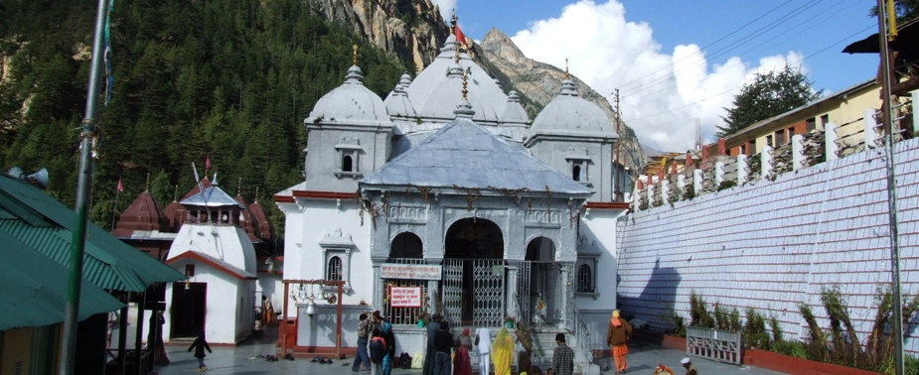

Day 05: UttarkashiGangotriUttarkashi (100kms/3-4 hrs each side) Height: 3048 MTS.
Early morning after breakfast drive to Gangotri, enroute at Gangnani take a holy dip in GaramKund, further drive to Gangotri via beautiful Harsil Valley. Harsil is famous for its nature beauty and for the majestic views of the Deodar trees, Mountains and Apple garden. On arrival at Shree Gangotri, take a holy dip in the sacred river Ganges which is also called Bhagirathi at its origin. Perform Pooja and Darshan, after that relax for some time in the lovely surroundings. Later drive back to Uttarkashi. Overnight stay at Uttarkashi.

Harsil:- Harsil, also known as the Mini Switzerland of India, Harsil is a village, located on the banks of the Bhagirathi River, on the way to Gangotri, a Hindu pilgrimage site in Uttarkashi district of the Indian state of Uttarakhand.
Ganges below Gangotri, near HarsilSituated at an altitude of 9,005 ft (2,745 metres.) from sea level, Harsil lies 78 km. from Uttarkashi, and 30 km away from the Gangotri National Park which is spread across 1,553 square km. The hill station is well- known for its natural environment and apple production.
For More Information visit Harsil.

Gangotri Temple: The temple was constructed by the Gorkha General Amar Singh Thapa in the 18th Century, is situated on the right bank of Bhagirathi. For More Information visit Gangotri.
Gangotri Weather - The maximum temperature during summer can go up to 20° Celsius. Summer nights can get cooler with a minimum temperature of 10° Celsius. Light woolen clothes are required while visiting Gangotri during summer. Winter season is very cold in Gangotri. Gangotri will be covered in sheets of snow during winter. Pilgrimage centers remains closed throughout winter due to heavy snow falls.
Day 06: UttarkashiGuptkashi (220kms/8-9hrs drive one way) Height: 1319 MTS.
Morning after breakfast, drive to Guptkashi via Moolgarh&Lambgoan. Enroute you can see the beautiful river Mandakini at Tilwara. The Mandakiniriver comes from Kedarnath, drive alongside the river to reach Guptakashi, visit ArdhNarishwar Temple in Guptakashi. Check into the hotel arrival in Guptakashi. Overnight stay at Guptakashi.
Guptakashi:-The name GuptKashi means "Hidden Kashi”. Mythology describes how when the Pandava brothers were searching for a glimpse of Shiva, Shivji first concealed himself at Guptkashi, but later fled from them further up the valley to Kedarnath, where the Pandavas finally got their wish fulfilled. There are more tangible connections as well-the Kedarnath pandas (priests) live in Guptkashi during the winter months, and after the Kedarnath temple closes for the winter, the image of Kedarnath passes through GuptKashi on its way to Ukhimath (across the valley), where it stays for the winter.
For More Information visit Guptkashi.
Guptkashi Weather - pleasant in summer, the temperature ranges from 25-30 degree Celsius. Cold in winters.
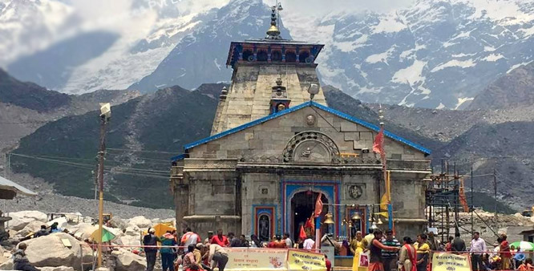
Day 07: Guptkashi //Kedarnath
Morning after breakfast, drive for Sonprayag for trekking of kedarnath. (You have to leave hotel too early in the morning). Overnight stay at Kedarnath.
By Helicopter: Morning our driver will transfer you to your pre-book Helipad. After coming back to helipad our car will drop you at Hotel for rest.

By Trek:Morning our driver will drop you at Sonprayag then you have to take local jeep for Gaurikund& then your trek will start for kedarnathji. After darshan you follow same & back to Sonprayag. There is a big parking issue so driver will park the vehicle at other place if his contact no. is not working then you have to arrange other taxi or wait for your driver & send the message any other.

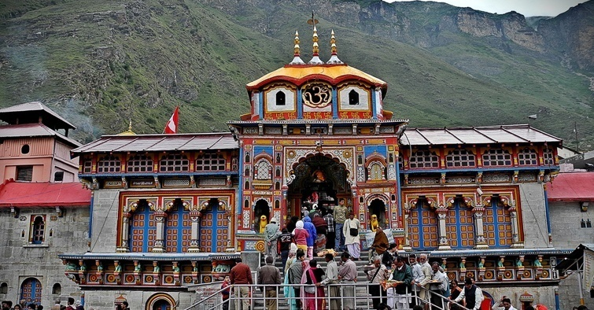

Day 08: Kedarnath//Guptkashi.
Morning visit kedarnath Temple for pooja and after breakfast, checkout from hotel. Overnight stay in Guptkashi.
Kedarnath: The Kedarnath shrine, one of the 12 Jyotirlingas of Lord Shiva, is a scenic spot situated, against the backdrop of the majestic Kedarnath range. Kedar is another name of Lord Shiva. According to legend, the Pandavas after having won over the Kaurava in the Kurukshetra war, felt guilty of having killed their own brothers and sought the blessings of Lord Shiva for redemption. He eluded them repeatedly and while fleeing took refuge at Kedarnath in the form of a bull. On being followed he dived into the ground, leaving his hump on the surface. The remaining portions of Lord Shiva appeared at four other places and are worshipped there as his manifestations. The arms appeared at Tungnath, the face at Rudranath, the belly at Madhmaheshwar and his locks (hair) with head at Kalpeshwar. Kedarnath and the four above-mentioned shrines are treated as PanchKedar.
For More Information Visit Kedarnath.

Kedarnath Weather - Due to its high altitude the weather in Kedarnath remains cold for most part of the year. Summer here is cool and pleasant while winter is severe. During summer season the temperature varies around 20°Celsius. Light woolen wear is recommended. Winter season in Kedarnath is severe with mercury falling to as low as 0°Celsius. During this time the place experiences snowfall as well. Due to the extreme climatic conditions, this time is usually avoided by tourists.

Day 09: GuptkashiBadrinath (220kms/9-10hrs) Height: 3133 MTS.
Morning after breakfast, drive to Badrinath. Check in to the hotel arrival in Badrinath. Pilgrims after having a bath in the Taptkund have the Darshan of Badrivishal&Aarti in evening. Brahamakapal is significant for PinddanShraddh of ancestors (Pitrus). There are other interesting sightseeing spot like Mana, VyasGufa, Maatamoorti, Charanpaduka, Bhimkund and the "Mukh" of the Saraswati River. Just within the 3 kms. of Badrinath ji. Overnight stay at Badrinath.

Badrinath ji is one of the 'Ancient Four Dhams' and one of the most celebrated pilgrimage spots of the country and is situated at an elevation of 3,133 meters, guarded on either side by the two mountain ranges known as Nar & Narayan with the towering Neelkanth Peak providing a splendid backdrop. This revered spot was once carpeted with wild berries. Thus the place got the name "Badri van", meaning "forest of berries".
For More Information Visit Badrinath.

TaptKund:Natural thermal springs on the bank of the river Alaknanda, where it is customary to bath before entering the Badrinath temple.

ManaVillage:Inhabited by an Indo-Mongolian tribe, it is the last Indian village before Tibet.

Vasundhara : As the name suggests, vasundhara is a magnificent water fall. This place is 5 kms. FromBadrinath out of which 2 kms.IsmotorableuptoMana.

BhimPul : On the other side of Mana village, a massive rock forming a natural bridge, lies over the roaring Saraswati river. It presents a spectacular view of water thundering down through the narrow passage under the rock and is believed to have been placed there by Bhim, the second eldest among the five Pandava brothers.

VyasGufa (cave): Near Mana Village, this is a rock-cave where VedVyas is believed to have composed the Mahabharata and the pauranic commentaries.

Badrinath Weather: The average maximum temperature will be around 18° Celsius and the average minimum is 8° Celsius. Warm and woolen clothes are hence required for a stay in Badrinath throughout the year. Winter in Badrinath is often accompanied by snow falls. Winter is very chilly with an average temperature of 5° Celsius. Due to the extreme climatic conditions, this time is usually closed for tourists.

Day 10: BadrinathJoshimathRudraprayag (160kms/7hrs drive one way) Height: 895 MTS.
Morning afterbreakfast, driver for Rudraprayag via Joshimath. Visit on the way Narsingh Temple in Joshimath later drive back to Rudraprayag via Joshimath. Check into the hotel arrival in Rudraprayag. Overnight stay at Rudraprayag.

Joshimath is situated on the slopes above the confluence of the rivers Alaknanda and Dhauliganga. Of the four 'Maths' established by AdiShankaracharya, Joshimath is the winter seat of Badrinath. The idol is brought down to Joshimath and installed in the temple for people to worship. There are many other temples in the township. The most important is the temple of NarSingh with the idol of Lord Vishnu. The left arm of this deity is getting destroyed with time and the popular belief holds that the day the arm completely withers Badrinath valley will cease to exist and the Gods will transfer the residence into the neighboring Niti Valley at BhavishyaBadri.
For More Information visit Joshimath.

Rudraprayag is one of the PanchPrayag (five confluences) of Alaknanda River. It is confluence of rivers Alaknanda and Mandakini. Kedarnath, a Hindu holy town is located 86 km from Rudraprayag.
For More Information visit Rudraprayag.

Rudraprayag Weather - Generally hot in summer, the temperature ranges from 35-40 degree Celsius, Winter: The Days are pleasantly cool but the nights are cold, temp ranges from 20 deg to 05 deg.

Day 11: RudraprayagRishikesh (140kms/5-6hrs.)
Morning after breakfast, drive for Rishikesh. Rishikesh 'place of sages' is celebrated as spiritual town on the bank of Ganga and is surrounded by Shivalik range of the Himalayas on three sides. It is said that when Raibhya Rishi did hard penances, God appeared by the name of " Hrishikesh " and this area hence firth came to be known as Rishikesh. Later visit Rishikesh Temples Sight Seeing – LaxmanJhulla, Ram Jhulla. Overnight stay at Rishikesh.

Rishikesh: Named after the Lord Vishnu, Rishikesh is a holy city for Hindus. Located in the foothills of the Himalaya in northern India it is also known as the yoga center of the world and is home to many world renowned ashrams. Rishikesh styles itself as the ‘Yoga Capital of the World’, with masses of ashrams and all kinds of yoga and meditation classes. The fast-flowing Ganges is surrounded by forested hills inside the city. Apart from temples and ashrams Rishikesh is now a popular white-water rafting centre, backpacker hang-out, and gateway to treks in the Himalaya.
For More Information visit Rishikesh.
Day 12: RishikeshDelhi (245kms/ 6-7hrs. Drive one way)
Morning after breakfast, drive for Delhi. Dropping at Delhi airport/ station/ home/ hotel.

Tour Completed with Pleasant and Almighty Blessings…

General Instructions
- Hotels suggested above is subject to availabilities on dates and prior confirmation and in case we do not find rooms in above hotels in any circumstances we will arrange the same in similar category hotels for parallel arrangements.
- Sitting arrangements in BUS /Tempo will be on rotation basis. Our representative will guide you for this and we need to cooperate with him.
- Charges for AC / Heater will be extra and as per hotel-to-hotel basis.
- AC will not operate on Hills.
- Vehicles are on Disposal from pre advised meeting point in Delhi.
- Transfers from Delhi are subject to availability of vehicle.
- It is mandatory to carry the age proof of children (02 to 11 yrs) and infant (below 02yrs) as well along with other travel documents. Child above than 11 yrs shall be considered for an adult cost.
- Room allocation (Twin bed / Double bed) is at the discretion of the hotel. The check in and checkout time of the hotel is 12 to 12 noon. Numbers of meals are always corresponding to the number of nights booked.
- Breakfast is not provided on the day of arrival.
Destination | Meals | Nights
Haridwar | Dinner + Breakfast | 01
Barkot | Breakfast + Dinner | 02
Uttarakashi | Breakfast + Dinner | 02
Guptkashi | Breakfast + Dinner | 01
Kedarnath | Pack Breakfast | 01
Guptkashi | Dinner | 01
Badrinath/Pandukeswar | Breakfast + Dinner | 01
Rudraprayag | Breakfast + Dinner | 01
Rishikesh | Breakfast + Dinner | 01

Note:
- As you know May & June is very peak season will serve you hotel same or similar as per availability?
- As you know Kedarnath Ji is situated very high attitude there is no any luxury facilities will sever you basic accommodation with sharing basis without any meals.

Cost includes:
- Hotel accommodation as per package same or similar hotels.
- Meals as per package
- Transfers and sightseeing as per itinerary.
- All toll tax, parking, fuel and driver allowances.
- All applicable taxes.
- 05% GST on bill.
Cost doesn’t include:
- Others meals does not include in Package.
- Anything not mentioned under ‘Package Inclusions’
- All personal expenses, optional tours and extra meals.
- Medical and travel insurance.
- Any kind of entry fees anywhere if not mentioned in including.
- Tips travel insurance, medical insurance, laundry charges, liquors, mineral water, telephone charges.
- All items of personal nature.
- For Yamunotri trek Porter, pony & horse include.
Refund:
- 30 Days before full Refund
- 15 Days before no refund.
Hotels Terms & Conditions:
- Please read emails carefully and understand the contents and prices. All the email conversations will be also part of your contract with us once you make the booking.
- There is no deluxe facilities in Kedarnathji due to high altitude. There only serve you bed system.
- As per the directive given by the Government of India, all Indian/Foreign Nationals are required to provide proper proof of identification upon check-in. valid identifications documents are: Passport & Visa together, Voters Id card, Current Drivers License, Aadhar Card. All the documents must include a photograph.
- Hotel / camps or any kind of accommodation can deny stay if valid id proof is not provided. Company is not responsible for any ID proof related issues.
- Generally hotel check in time is 14:00 hrs and checkout time is 11:00 hrs across India. Confirm early check in or late checkout will be chargeable if not included in cost. Kindly contact hotel directly if you want complimentary early check in or late check out.
- If meals are included in package it will be served at set menu basis in a buffet menu / fixed / meal credit. Any items which are not in their in ideal Buffet / Fixed menu will be charged extra at the time of consumption. Hotels decide the menu and options of items for menu. Some hotels having Meal credit policy instead of Buffet or Fixed Menu during low occupancy in hotel – This meal credit amount is decided by hotel management – if bills goes above the given meal credit amount then extra amount should be paid directly at respective hotel. Room service for the food or packing is charged extra at many hotels. Normally in Chardham you will get north Indian type food only and most of the standard and deluxe hotels give thali if meals are included in package.
- Breakfast Timing: 07:00 Am to 09:00 AM And Dinner: 07:00 PM to 10:00 PM (About the timing you can contact hotel management before.)
- Normally for extra bed on double sharing rooms many hotels has rollaway bed while rest of the hotels provide extra mattress only. If you are not comfortable with mattress system instead of bed let us know in advance.
- In hill areas or Chardham many hotels don’t have ac so if you insist ac only kindly confirm with the company regarding the same. Lift facility & power back up is not available in most of the hotels in Chardham. Wifi facility and room heater is mostly chargeable but don’t expect good wifi in Chardham hotels due to network issues most of the time.
- Most of the hotels in Chardham are not running full year so don’t expect similar service and room quality like you get in Haridwar Rishikesh in the same price range. Especially in may June and other busy days the budget/standard hotels in Chardham can cost more than deluxe hotel in Haridwar Rishikesh or Delhi. Also if you want to stay good hotels with good reviews you need to book at least 3 months before in may June and 1-2 month before in Oct Nov season as good hotels are mostly booked in advance by groups. In Kedarnath there is only basic dharamshala / budget hotel type basic facility only even if your package isluxury in Kedarnath don’t expect even deluxe rooms.
Vehicle Terms & Conditions:
- AC will not work in all hill areas or stopped / parked vehicle. Hill areas will start from Dehradun onwards as well from Rishikesh onwards and ac will not work beyond those points.
- Vehicle will be permitted to use for sightseeing points on the route and inside the city limits or which is mentioned in itinerary. For additional sightseeing, off route sightseeing, sightseeing not inside the city limits or substitute sightseeing kindly contact company. Refund is not possible if any particular sightseeing point is not covered. In case you want some excursions kindly inform company in advance or discuss these things with company rather than driver. All nearby sightseeing points should be covered together. However in case of sometime issues with some particular place we can adjust. In Chardham route some of the places are not on the way like Trijuginarayan, Lakhamandal, Auli, Kalimath, Neelkanth Mahadev, AdiBadri, BhavishyaBadri etc. Kindly contact directly to company in case you want to include these places rather than driver.
- Due to any reason if Vehicle breakdown due to technical reasons we will try our best to arrange another vehicle as soon as possible for the major problems. For minor problems which will not take much time vehicle will be repaired. Kindly cooperate.
- We shall not be responsible for any delays & alterations in the program or expenses incurred directly or indirectly due to natural hazards, flight cancellations, accident, breakdown of transport, weather, sickness, landslides, closures/blockades due to political unrest or any such incidents.
- In case the driver is not cooperative kindly contact company on the spot.
- Driver will not drive on No-entry zones and should not be forced to drive on narrow streets or roads which can create traffic jam. Normal working hours of driver is 12 hrs in case you want services more than 12 hours in a day kindly inform us in advance.
- In some hill area roads driving after sunset and music is not allowed due to risk of life. Kindly cooperate for the same.
- Pick up and drop point will be one only (If multiple pickups and drop please mentions email conversation before booking)
- In case you want multiple visit to the some particular place kindly mention in advance because some places are having very high charges of parking.
- Tour destination / route cannot change without prior notice (Amended route and tour Destination rates may be change)
- The rates are subject to change, depending on the fluctuation of diesel/Petrol prices in India. If the prices increased more than 5 % than the time of booking we will increase the rate even if the rates are confirmed earlier.
- Company reserves the right to give you a similar car if the car you booked is unavailable.
- At many of the tourist destination / hill station - some of the road / shopping market / mall road have "NO ENTRY" for all / some bigger tourist vehicles depends on destination along with time restrictions also. In this kind of situation guest have to manage another available mode of transport with an additional cost and on direct payment basis, this cost is not included in ideal package inclusion.
- Some time vehicle parking area little far from the sightseeing spots. Guests need to reach the parking at their own cost.
- No refund for short stay or unveiled facilities.
- No cancellation or any refund will be made if situation is beyond our control, such as bad weather, landslide, climatic conditions or any other natural disaster, fire, any embargo, acts or decisions of government, political or national crisis, road blocks, heavy snow fall, acts of terrorism or other similar causes, strikes or problems at airlines, rails, buses, hotels or transporters, labor unrest, insolvency, business exigencies, operational and technical issues, route and flight cancellations or due to which the customer could not reach the destination and which is beyond our control.
- Company is not responsible for any accident/injury/death/theft of person or property during the course of the tour.
- All rights reserved to management to cancel any service without any refund until full advance amount towards the service is received from the customer and accepted by company.
- Company Here by expressly disclaims any implied warranties imputed by the laws of any jurisdictions or country other than India. Company considers itself and intends to the jurisdictions only of the court of Haridwar, Uttarakhand India.

